**Creating Microservices for account and loan**

***Account Microservice :***

* 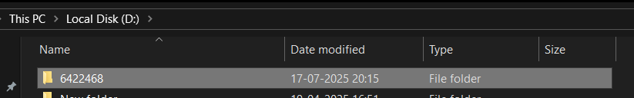**Create folder with employee id in D: drive :**

**=**

* **Create folder named 'microservices' in the new folder created in**

**previous step. This folder will contain all the sample projects that we will**

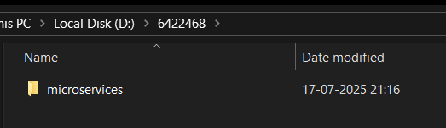**create for learning microservices.**

**=**

* **Open https://start.spring.io/ in browser**
* **Enter form field values as specified below:**
* **Group: com.cognizant**
* **Artifact: account**
* **Select the following modules**
* **Developer Tools > Spring Boot DevTools**
* **Web > Spring Web**
* **Click generate and download the zip file**

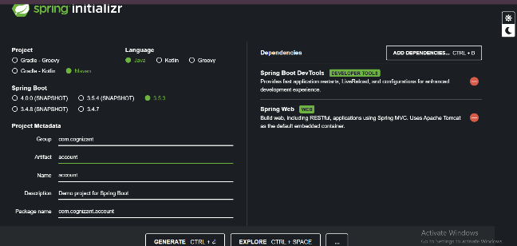**=**

* **Extract 'account' folder from the zip and place this folder in the**

**'microservices' folder created earlier**

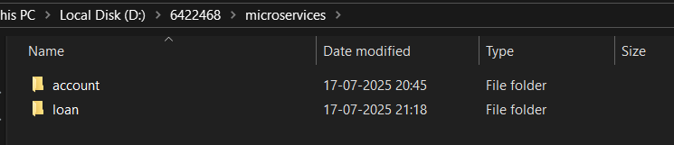**=**

* **Open command prompt in account folder and build using mvn clean**
* **package command**
* **Import this project in Eclipse and implement a controller method for**
* **getting account details based on account number. Refer specification**
* **below:**
* **Method: GET**
* **Endpoint: /accounts/{number}**
* **Sample Response. Just a dummy response without any backend**
* **connectivity.**
* **{ number: "00987987973432", type: "savings", balance: 234343 }**

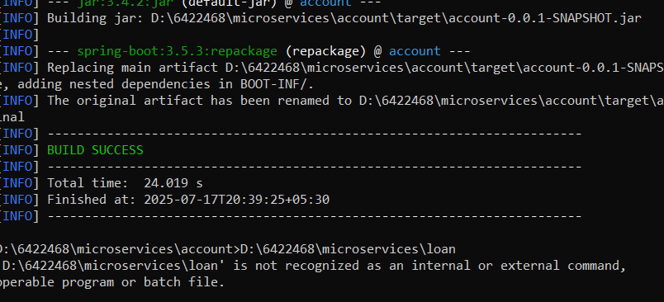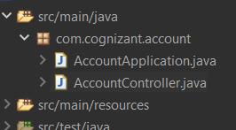

**=**

***AccountController.java:***

=

package com.cognizant.account;

import org.springframework.web.bind.annotation.GetMapping;

import org.springframework.web.bind.annotation.PathVariable;

import org.springframework.web.bind.annotation.RestController;

import java.util.HashMap;

import java.util.Map;

@RestController

public class AccountController {

@GetMapping("/accounts/{number}")

public Map<String, Object> getAccountByNumber(@PathVariable String number) {

Map<String, Object> account = new HashMap<>();

account.put("number", number);

account.put("type", "savings");

account.put("balance", 50000);

return account;

}

}

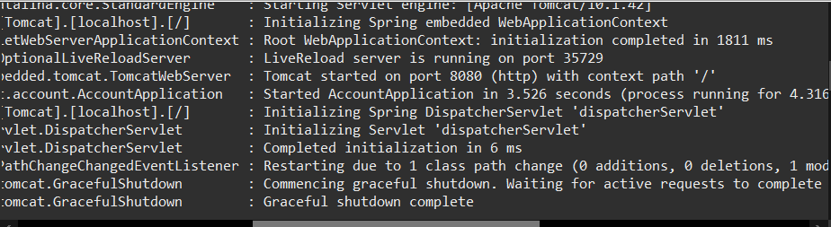***Output of AccountApplication:***

* **Launch by running the application class and test the service in browser**

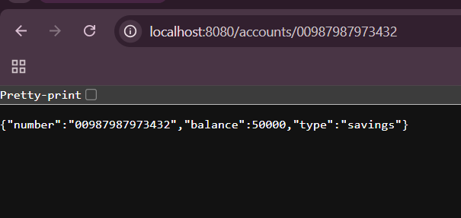**=**

**--------------------------------------------------------------------------------------------------------------------------**

**Loan Microservice:**

* **Follow similar steps specified for Account Microservice and implement a service API to get loan account details o Method: GET o Endpoint: /loans/{number} o Sample Response. Just a dummy response without any backend connectivity. { number: "H00987987972342", type: "car", loan: 400000, emi: 3258, tenure: 18 }**

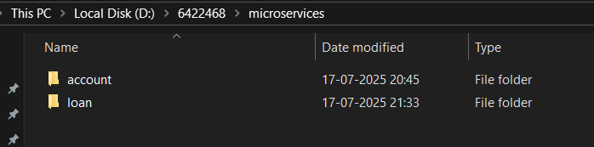=

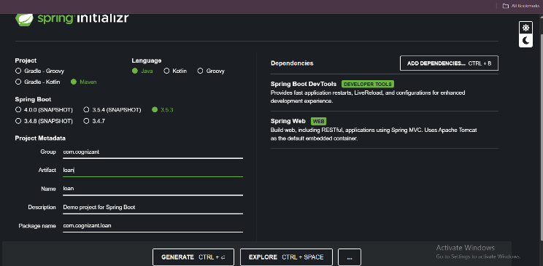

**Spring creation:**

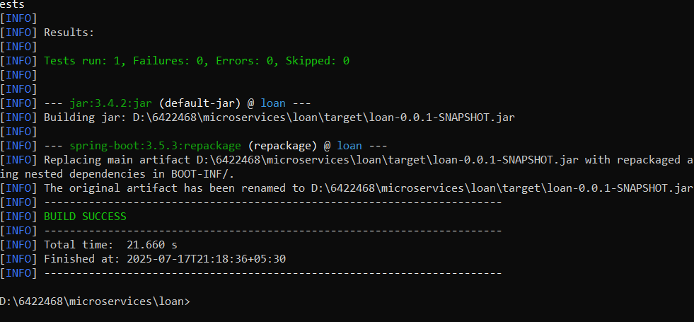MAVEN BUILD IMPORT PROJECT:

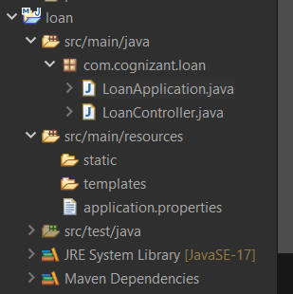

***LoanController.java:***

package com.cognizant.loan;

import org.springframework.web.bind.annotation.RestController;

import org.springframework.web.bind.annotation.PathVariable;

import org.springframework.web.bind.annotation.GetMapping;

import java.util.Map;

import java.util.HashMap;

@RestController

public class LoanController {

@GetMapping("/loans/{number}")

public Map<String, Object> getLoanByNumber(@PathVariable String number) {

Map<String, Object> loan = new HashMap<>();

loan.put("number", number);

loan.put("type", "car");

loan.put("loan", 400000);

loan.put("emi", 3258);

loan.put("tenure", 18);

return loan;

}

}

***application.properties file:***

spring.application.name=loan

server.port=8081

***OUTPUT OF LoanApplication:***

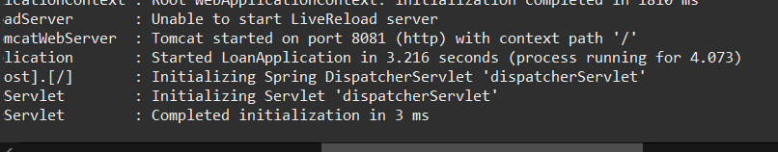

* **Launch by running the application class and test the service in browser:**

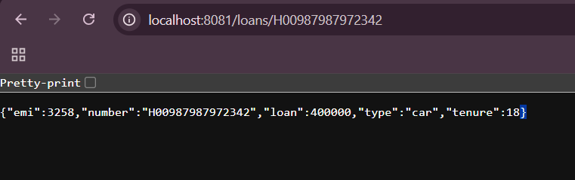**=**

**.So, we have implemented accounts and loan. Both are running in different ports . we can see them by toggling the console**

**ASSIGNMENT DETAILS:**

NAME: SWARNADRI SEKHAR MUKHERJEE